# world athlete track academy feb 2010 *10th SUMMER TRACK & FITNESS FUN CAMPS*

***Camps conveniently located at Moorestown HS, Moorestown NJ***

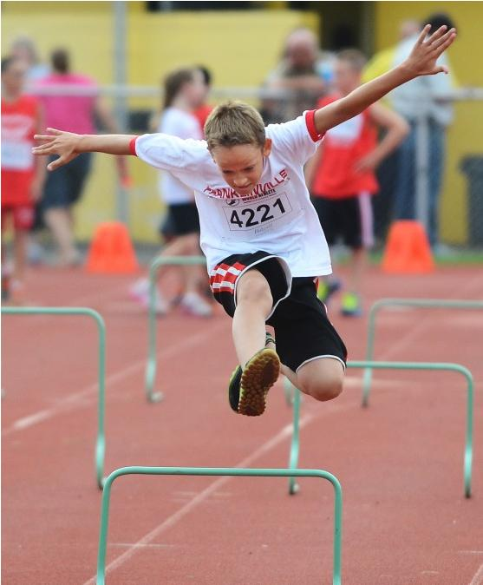



**Track and Fitness Camps Pole Vault Camps Throwing Camps Distance Camps**

**July 7-11, 2014 July 7-11, 2014 July 7-11, 2014 July 7-11, 2014  
 July 14-18, 2014 July 14-18, 2014   
 July 21-25, 2014 July 21-25, 2014**

Track & Fitness Camp 8:30am - 3:00pm $299/week

**Track & Fitness Mini Camp 8:30am - 12:00pm $199/week**

Throws Mini Camp 8:30am - 12:00pm $199/week $299/week*

Pole Vault Mini Camp 8:30am - 12:00pm $199/week $299 week*

**Distance Mini Camp 8:30am - 12:00pm $199/week $299/week\***

*All skill levels are welcome! Track and Field camps are for children preK-12th grade. Track, Distance, Pole Vault and Throws mini camps are for 7th-12th graders. *Athletes may enroll in a mini specialty camp in the morning and the track camp in the afternoon for $299.*

*All programs include instruction, World Athlete T-shirt &World Athlete Track Meet entry fees.*

Sprinting

Hurdling

Jumping

Relays

Weight Training

Conditioning

Recreation Time

**Arts & Crafts**

**Board Game Tournaments**

**Weekly Track Meets**

**Obstacle Courses**

**Parachute Racing**

**All of the World Athlete summer track meets are open to the public. All ages and skill levels are welcome to enter. Online registration and more Information is available on our website.**

**609-304-2902** [**coach@worldathlete.net**](mailto:coach@worldathlete.net)[**www.worldathlete.net**](http://www.worldathlete.net)

**Facebook.com/worldathlete Twitter: WorldAthlete**

**(Application on reverse side)**

## 2014 WORLD ATHLETE SUMMER TRACK ACADEMY

**ATHLETE REGISTRATION**

**Select your week(s) School: _______________**

**___ WEEK 1 (July 7-11) ___ WEEK 2 (July 14-18)**

**___ WEEK 3 (July 21-25)**

**Please circle one (for athletes grades pre K -6): Track Camp Track Mini Camp**

**Please circle (for athletes grades 7-12): Track Camp, Distance Camp, Distance & Track Camps, Pole Vault Camp, Pole Vault & Track Camps, Throws Camp, Throws & Track Camp**

**Name ______________________________________________________ Age ___ Sex ___**

**Address** **______________________________________________________ Birth Date ______________**

**City** **__________________________ State ____ Zip ___________**

**T Shirt Size: Youth S Youth M Youth L Small Medium Large Extra Large**

**Home Phone _______________________ Email ___________________________________**

**Parent/Guardian Name ________________________________________**

**Parent/Guardian contact #** **________________________________________**

**Emergency Contact Name** **________________________________________**

**Emergency Contact #** **________________________________________**

**RELEASE:**

**I certify that my child is in excellent health and may participate in strenuous activities including track and field. I agree to hold World Athlete, LLC, World Athlete Academy, its affiliates, partners, coaches, staff, heirs, volunteers, school districts and towns harmless from any and all claims of injuries sustained by my child during his/her participation in the Academy. Permission is hereby granted to use pictures of participants in any promotional materials, including online postings. Permission is hereby granted for my child to receive medical treatment if needed. I certify that there are no limits on my child’s participation except as stated in writing and included with this release form.**

**Parent/Guardian Signature ________________________________ Date ______________**

**PAYMENT OPTIONS:**

**1) Make your check/money order payable to:**

**World Athlete Track Academy**

**4 Marcy Court**

**Mt. Laurel NJ 08054**

**2) Credit Cards Accepted: MasterCard, Visa and Discover**

**Card #: ____________________________________ Exp. Date (MM/YYYY) _______**

###### Print Name: ________________________________

###### Signature __________________________________ Date _____________________

**DISCOUNTS:**

**Family Discount: Available to any family that registers 3 or more children for 1 Academy week. After the first fully paid registration, a 5% discount will be deducted from the registration fee of all remaining children. Multi-Week Discount: Available to athletes signing up for 2 weeks or more Academy weeks. After the first fully paid Academy week, $10 will be deducted from the fee of each subsequent Academy week.**

**Team Discount: Contact us for information. Discounts cannot be combined. Call us for information.**

#### ACADEMY CANCELLATION AND REFUND POLICY:

**We reserve the right to cancel Academy sessions at our discretion. All athlete requests for cancellation must be made in writing to World Athlete Track Academy. All monies paid, with the exception of a $75 administrative fee, will be refunded provided the notice of cancellation is received two weeks prior to the start of the Academy. No refunds will be provided after this time.**