HELP SUPPORT OUR MEET WITH A PROGRAM GUIDE ADVERTISEMENT





5th Moorestown Invitational Boys Track Meet
April 9, 2011
Moorestown High School
Moorestown, New Jersey

The Moorestown Invitational is the annual fundraiser for the Moorestown High School boys track team. Proceeds from the event go to meet equipment and awards, team uniforms and athlete recognition awards. Now in its 5th year, the Moorestown Invitational attracts more than 40 teams and 1,200 athletes from Central and South Jersey. Hundreds of coaches, officials and parents attend the meet. There are 24 events for high school & middle school athletes.

You can help our fundraising effort by placing an advertisement in the meet program guide. Last year’s guide sold out! The guide is black and white with a color cover. All camera ready ads, ad pdf files or Word files must be received by April 5.

Make checks payable to the Moorestown Boys Spring Track Fundraising Fund
Thank you for your support!
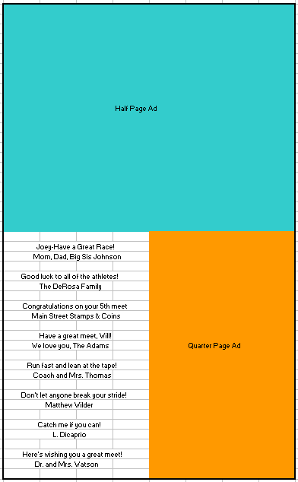

Program Guide Advertisement Rates

Full page 8 ½” x 11” $250
Half page 4 ¼” x 5 ½” $125
Quarter page 2 1/8” x 2 ¾” $ 75
2 line Greeting $ 25

Ad size: Full Half Quarter 2 Line

Contact Name: ________________________

Email: _______________________________

Phone: ______________________________

Send ad and this information by April 5 to
coach@worldathlete.net or mail them to:
Moorestown Invitational Program Guide
4 Marcy Court
Mt. Laurel NJ 08054
Questions?
Troy Pappas, Meet Director
coach@worldathlete.net
609-304-2902

